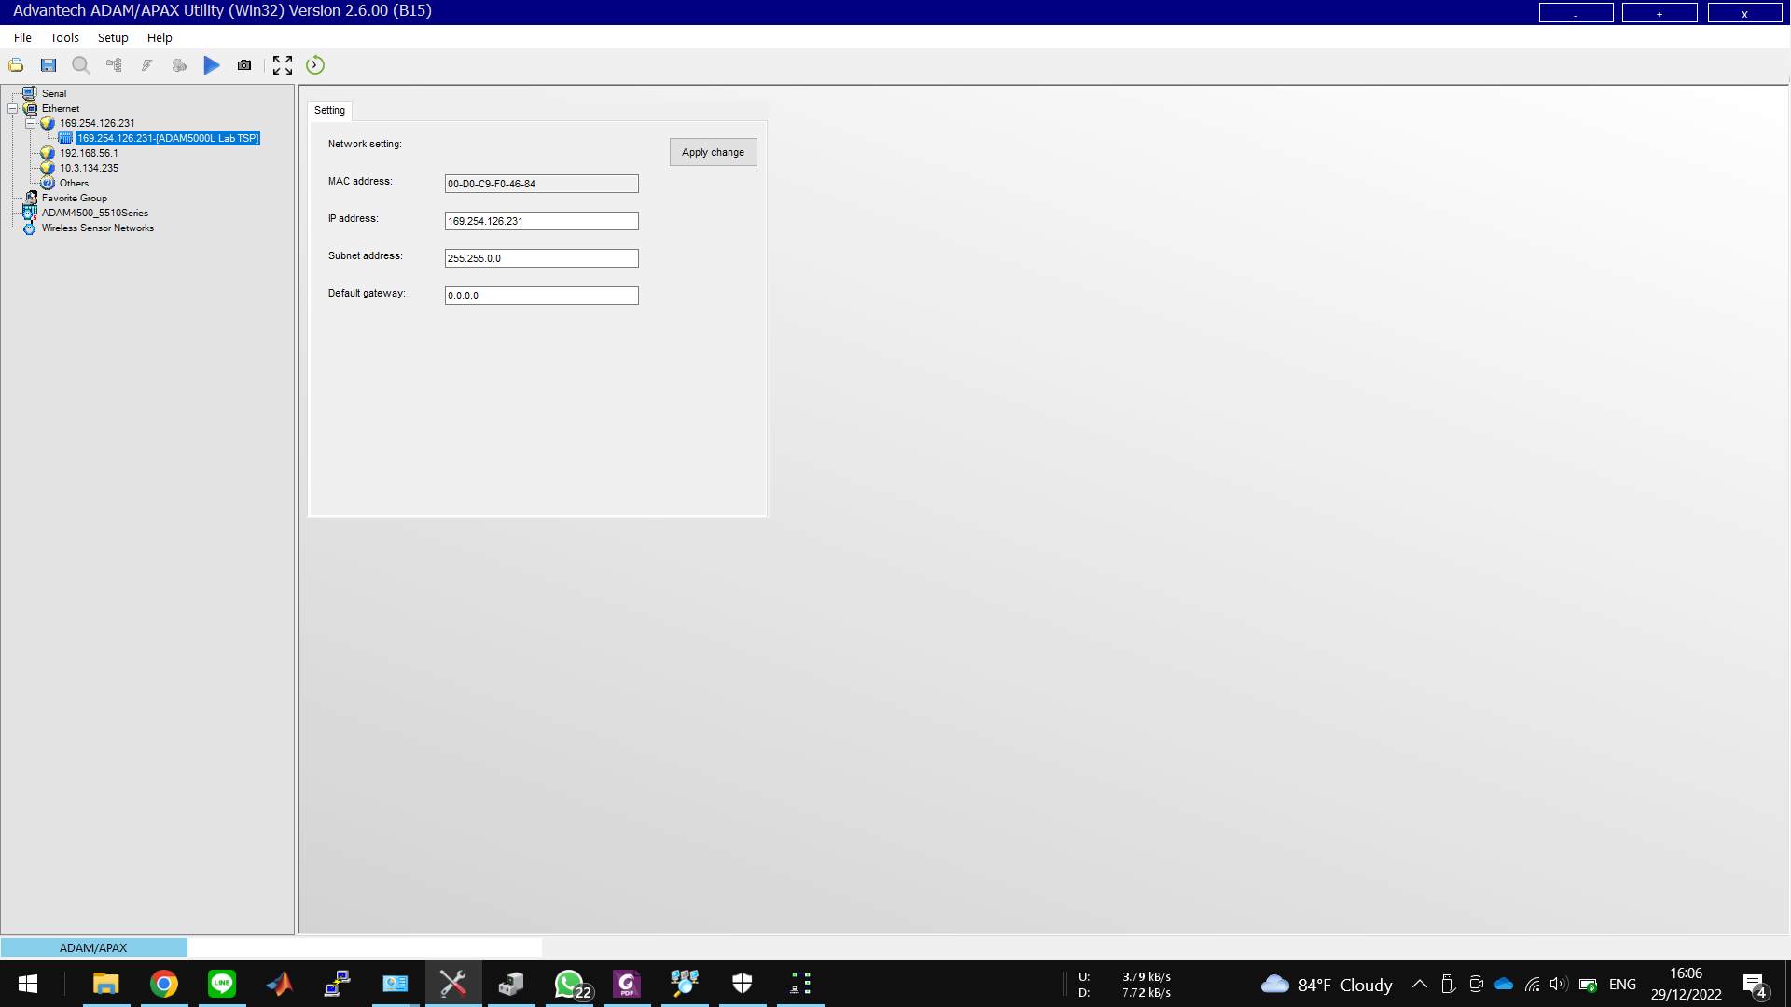

Windows IP Configuration

Host Name . . . . . . . . . . . . : LAPTOP-LV46M3MI

Primary Dns Suffix . . . . . . . :

Node Type . . . . . . . . . . . . : Mixed

IP Routing Enabled. . . . . . . . : No

WINS Proxy Enabled. . . . . . . . : No

DNS Suffix Search List. . . . . . : www.ee.its.ac.id

Unknown adapter Local Area Connection:

Media State . . . . . . . . . . . : Media disconnected

Connection-specific DNS Suffix . :

Description . . . . . . . . . . . : TAP-Windows Adapter V9 for OpenVPN Connect

Physical Address. . . . . . . . . : 00-FF-10-8F-5F-59

DHCP Enabled. . . . . . . . . . . : No

Autoconfiguration Enabled . . . . : Yes

Wireless LAN adapter Local Area Connection* 1:

Media State . . . . . . . . . . . : Media disconnected

Connection-specific DNS Suffix . :

Description . . . . . . . . . . . : Microsoft Wi-Fi Direct Virtual Adapter

Physical Address. . . . . . . . . : 9C-FC-E8-67-1A-84

DHCP Enabled. . . . . . . . . . . : Yes

Autoconfiguration Enabled . . . . : Yes

Wireless LAN adapter Local Area Connection* 2:

Media State . . . . . . . . . . . : Media disconnected

Connection-specific DNS Suffix . :

Description . . . . . . . . . . . : Microsoft Wi-Fi Direct Virtual Adapter #2

Physical Address. . . . . . . . . : 9E-FC-E8-67-1A-83

DHCP Enabled. . . . . . . . . . . : No

Autoconfiguration Enabled . . . . : Yes

Ethernet adapter Ethernet:

Connection-specific DNS Suffix . :

Description . . . . . . . . . . . : RD9700 USB2.0 To Fast Ethernet Adapter

Physical Address. . . . . . . . . : 00-E8-01-4B-94-8D

DHCP Enabled. . . . . . . . . . . : No

Autoconfiguration Enabled . . . . : Yes

Link-local IPv6 Address . . . . . : fe80::4456:e4ac:c247:759c%7(Preferred)

IPv4 Address. . . . . . . . . . . : 10.0.0.2(Preferred)

Subnet Mask . . . . . . . . . . . : 255.255.0.0

Default Gateway . . . . . . . . . : 10.0.0.254

DHCPv6 IAID . . . . . . . . . . . : 117499905

DHCPv6 Client DUID. . . . . . . . : 00-01-00-01-29-64-3A-44-9C-FC-E8-67-1A-83

DNS Servers . . . . . . . . . . . : 10.0.0.1

NetBIOS over Tcpip. . . . . . . . : Enabled

Wireless LAN adapter Wi-Fi:

Connection-specific DNS Suffix . : www.ee.its.ac.id

Description . . . . . . . . . . . : Intel(R) Wireless-AC 9560 160MHz

Physical Address. . . . . . . . . : 9C-FC-E8-67-1A-83

DHCP Enabled. . . . . . . . . . . : Yes

Autoconfiguration Enabled . . . . : Yes

Link-local IPv6 Address . . . . . : fe80::571b:4fb2:be41:7481%15(Preferred)

IPv4 Address. . . . . . . . . . . : 10.3.134.235(Preferred)

Subnet Mask . . . . . . . . . . . : 255.255.248.0

Lease Obtained. . . . . . . . . . : 29 December 2022 14:03:40

Lease Expires . . . . . . . . . . : 29 December 2022 17:04:28

Default Gateway . . . . . . . . . : 10.3.128.1

DHCP Server . . . . . . . . . . . : 10.3.128.2

DHCPv6 IAID . . . . . . . . . . . : 144506088

DHCPv6 Client DUID. . . . . . . . : 00-01-00-01-29-64-3A-44-9C-FC-E8-67-1A-83

DNS Servers . . . . . . . . . . . : 202.46.129.2

202.46.129.3

NetBIOS over Tcpip. . . . . . . . : Enabled

**KONFIGURASI WORKED by Faris 29 Des 2022**

Bila pada menu dropdown Ethernet tidak muncul IP v4 yang sesuai dengan LAN adapter, restart program (close n open again).

Windows IP Configuration

Host Name . . . . . . . . . . . . : LAPTOP-LV46M3MI

Primary Dns Suffix . . . . . . . :

Node Type . . . . . . . . . . . . : Mixed

IP Routing Enabled. . . . . . . . : No

WINS Proxy Enabled. . . . . . . . : No

DNS Suffix Search List. . . . . . : www.ee.its.ac.id

Unknown adapter Local Area Connection:

Media State . . . . . . . . . . . : Media disconnected

Connection-specific DNS Suffix . :

Description . . . . . . . . . . . : TAP-Windows Adapter V9 for OpenVPN Connect

Physical Address. . . . . . . . . : 00-FF-10-8F-5F-59

DHCP Enabled. . . . . . . . . . . : No

Autoconfiguration Enabled . . . . : Yes

Wireless LAN adapter Local Area Connection* 1:

Media State . . . . . . . . . . . : Media disconnected

Connection-specific DNS Suffix . :

Description . . . . . . . . . . . : Microsoft Wi-Fi Direct Virtual Adapter

Physical Address. . . . . . . . . : 9C-FC-E8-67-1A-84

DHCP Enabled. . . . . . . . . . . : Yes

Autoconfiguration Enabled . . . . : Yes

Wireless LAN adapter Local Area Connection* 2:

Media State . . . . . . . . . . . : Media disconnected

Connection-specific DNS Suffix . :

Description . . . . . . . . . . . : Microsoft Wi-Fi Direct Virtual Adapter #2

Physical Address. . . . . . . . . : 9E-FC-E8-67-1A-83

DHCP Enabled. . . . . . . . . . . : No

Autoconfiguration Enabled . . . . : Yes

Ethernet adapter Ethernet:

Connection-specific DNS Suffix . :

Description . . . . . . . . . . . : RD9700 USB2.0 To Fast Ethernet Adapter

Physical Address. . . . . . . . . : 00-E8-01-4B-94-8D

DHCP Enabled. . . . . . . . . . . : No

Autoconfiguration Enabled . . . . : Yes

Link-local IPv6 Address . . . . . : fe80::4456:e4ac:c247:759c%7(Preferred)

IPv4 Address. . . . . . . . . . . : 10.0.0.2(Preferred)

Subnet Mask . . . . . . . . . . . : 255.255.0.0

Default Gateway . . . . . . . . . : 10.0.0.254

DHCPv6 IAID . . . . . . . . . . . : 117499905

DHCPv6 Client DUID. . . . . . . . : 00-01-00-01-29-64-3A-44-9C-FC-E8-67-1A-83

DNS Servers . . . . . . . . . . . : 10.0.0.1

NetBIOS over Tcpip. . . . . . . . : Enabled

Wireless LAN adapter Wi-Fi:

Connection-specific DNS Suffix . : www.ee.its.ac.id

Description . . . . . . . . . . . : Intel(R) Wireless-AC 9560 160MHz

Physical Address. . . . . . . . . : 9C-FC-E8-67-1A-83

DHCP Enabled. . . . . . . . . . . : Yes

Autoconfiguration Enabled . . . . : Yes

Link-local IPv6 Address . . . . . : fe80::571b:4fb2:be41:7481%15(Preferred)

IPv4 Address. . . . . . . . . . . : 10.3.134.235(Preferred)

Subnet Mask . . . . . . . . . . . : 255.255.248.0

Lease Obtained. . . . . . . . . . : 29 December 2022 14:03:40

Lease Expires . . . . . . . . . . : 29 December 2022 17:04:28

Default Gateway . . . . . . . . . : 10.3.128.1

DHCP Server . . . . . . . . . . . : 10.3.128.2

DHCPv6 IAID . . . . . . . . . . . : 144506088

DHCPv6 Client DUID. . . . . . . . : 00-01-00-01-29-64-3A-44-9C-FC-E8-67-1A-83

DNS Servers . . . . . . . . . . . : 202.46.129.2

202.46.129.3

NetBIOS over Tcpip. . . . . . . . : Enabled